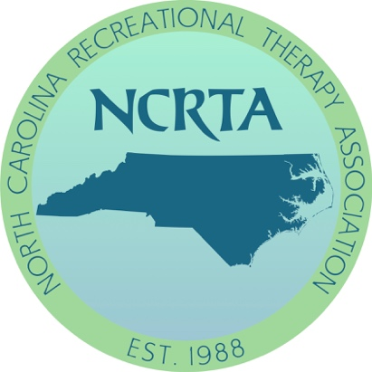

2020 NCRTA Student & Professional Issues Forum
Call for Papers
Hosted by North Carolina Central University
In Durham, NC

Friday, February 21st, 2020

For additional information please visit the NCRTA website at www.ncrta.org or
Email John Rhodes at ncrtaceuchair@gmail.com.

Call for Papers Deadline: Friday, December 13th, 2019
Please read all guidelines below to better assist you when completing a call for papers. Please complete application in this word document and add a copy of your resume at the end. Then upload your document at the bottom of the NCRTA homepage or email it to John Rhodes at ncrtaceuchair@gmail.com. An email will be sent to prospective presenters with updates as we get responses from ATRA.

ATRA Criteria for Awarding of CEUs

The Review and approval of CEUs are based on the following quality indicators:

- Speaker qualifications and competency on the topic being presented*

- Session content and relevance to the NCTRC Job Analysis, NCTRC recertification standards, and the therapeutic recreation profession

- Relevance of learning outcomes to subject matter

- Appropriateness of instructional methods based on subject matter*

- Session outline, including topics and teaching methods included

- Evaluation of learning outcomes*

- Attendance verification records*
*indicates a CEU requirement of ATRA, not NCTRC

SESSION PROPOSAL

Speaker Name & Titles to Appear on Brochure: NOTE: One speaker per presentation will be allowed free registration

Title of Session: 20 words of less; descriptive of content; related to NCTRC job analysis. Must contain Recreational Therapy in the Title.

Session Description: 150 words of less; descriptive of content; related to NCTRC job analysis. Must contain Recreational Therapy in the description.

Speaker Qualifications: Attach a Maximum of 2-page vitae or resume at the end of this document, OR provide a 400-word biographical sketch (briefer bios and references are not acceptable) Describe qualifications to present this topic

Instructional Methods: Instructional methods used in session (e.g., lecture, discussion, interactive, debate, panel, experiential, etc.)

Preferred Room Set Up:

Preferred Time for Session:

Learning Outcomes: Provide measurable learning outcomes for each session; Related to NCTRC job Analysis.

Examples of acceptable learning outcomes below:

By the end of the session the CTRS will be able to:
  - Identify three benefits of performing evidence-based TR practice
  - Perform an internet search for a clinical question related to TR practice.
  - Provide an example of using evidence-based practice in daily TR service delivery.

Examples of unacceptable learning outcomes:
Participants will:
- Improve knowledge of the topic
- Understand public policy
- Gain an understanding of the dementia practice guideline
- Participate in discussion
- Learn how to have fun!

Target Audience (circle all that apply): Entry level Professional Educator Student

​NOTE: Sessions geared only to students will not be reviewed by ATRA and NCTRC for CEU approval.

Session Outline: Provide a detail session outline of content and methodology.
* ​Please include "Recreational Therapy" in the outline
- (___ minutes)
- (___ minutes)
- (___ minutes)
- (___ minutes)
- (___ minutes)
- (___ minutes)
Total (should equal session length) __90___ minutes

The Following is an example of a Session Outline:
- ​Introduction of presenter (5 minutes)
- Short quiz on RT benefits (5 minutes)
- Quiz discussion and how it effects Recreational Therapy (5 minutes)
- Self-determination theory overview (15 minutes)
- Autonomy-supportive environment vs. a controlled environment (20 minutes)
- Autonomy-supportive environment techniques (10 minutes)
- Break into small groups- Discuss agency specific populations (20 minutes)
- Wrap up and evaluation (10 minutes)
NCTRC Job Analysis Area
Identify one to two of the most prominent areas of content of this session:

___ Foundational Knowledge (FKW)
___ Assessment Process (ASP)
___ Documentation (DOC)
___ Implementation (IMP)
___ Administration of TR/RT Programs (ADM)
___ Advancement of the Profession (ADV)

NOTE: To be consistent with the NCTRC Certification Standards, ATRA does not provide CEUs for a CE opportunity that is primarily activity based or experiential in nature, in which a specific activity or modality is taught. However, you may submit a session for review if at least 50% of the session relates to learning about the rationale, supporting research evidence, therapeutic process, and/or anticipated client outcomes (e.g., benefits, related research/evidence, assessment, implementation, program design, risk management, etc.) so that the session is not entirely focused on skill acquisition. An outline of the session will be required with this type of submission):

Special Notes and Requests:
Speakers contact information:
Email:
Phone Number:
Submit to: ncrtaceuchair@gmail.com
DEADLINE: December 13th, 2019.

