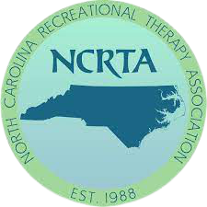

The North Carolina Recreational Therapy Association
Call for Papers

NCRTA is seeking 60 minute and 90 minute sessions. Please fill out the form below and submit to ncrtaceuchair@gmail.com.

SPEAKER NAME(S):

Title of Session:

Session Description:

Session Length (60 minutes or 90 minutes):

Speaker Qualifications: (please submit a resume in word format)

Preferred Day of the week for Session:

Learning Outcomes:

Target Audience (circle all that apply): Entry level Professional Educator Student

​

Session Outline:

Example:
- Introduction/Learning Objectives (5 minutes)
- Overview (20minutes)
- Discussion (20 minutes)
- Identify Factors (20 minutes)
- Educate (20 minutes)
- Q & A (5 minutes)

NCTRC Job Analysis Area
Identify one to two of the most prominent areas of content of this session:

___ Foundational Knowledge (FKW)
___ Assessment Process (ASP)
___ Documentation (DOC)
___ Implementation (IMP)
___ Administration of TR/RT Programs (ADM)
___ Advancement of the Profession (ADV)

Special Notes and Requests:
Speakers contact information:
Email:
Phone Number:
Submit to: ncrtaceuchair@gmail.com

