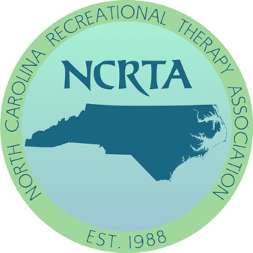

2021 NCRTA Virtual Conference
Call for Papers
Virtual Conference

February 2021

Our virtual conference will be spread out over the month of February.
We will be having live presentations set up in the evening from 7:00-8:30 pm.
We are looking for 60-minute and 90-minute sessions.
Please fill out the form below and submit to ncrtaceuchair@gmail.com by Dec 15th, 2020

SPEAKER NAME(S):

Title of Session:

Session Description:

Session Length (60 minutes or 90 minutes):

Speaker Qualifications: (please submit a 1 - 2-page resume in word format)

Preferred Day of the week for Session:

Dates when the speaker(s) will be unavailable in February 2021 (7-8:30 pm):

Learning Outcomes:

Target Audience (highlight all that apply): Entry level Professional Educator Student

​

Session Outline:

Example:
- Introduction/Learning Objectives (5 minutes)
- Overview (20minutes)
- Discussion (20 minutes)
- Identify Factors (20 minutes)
- Educate (20 minutes)
- Q & A (5 minutes)

NCTRC Job Analysis Area
Identify one to two of the most prominent areas of content of this session:

___ Foundational Knowledge (FKW)
___ Assessment Process (ASP)
___ Documentation (DOC)
___ Implementation (IMP)
___ Administration of TR/RT Programs (ADM)
___ Advancement of the Profession (ADV)

Would you be willing to allow NCRTA to record this and play it back at another time? *This is specifically to the recording done in February, your presentation and info is still yours to use again.

Special Notes and Requests:
Speakers contact information:
Email:
Phone Number:
Submit to: ncrtaceuchair@gmail.com

